Assignment 6

## **Task 1:Categorization — quick breakdown and why**

**1) “Generate a logo for a tech startup using neon colors.”** **Type:** Visual / Creative (Design Instruction)  
 **Why:** The request asks for an image-based deliverable (a logo) and gives stylistic direction (neon colors). It’s a creative design prompt meant to produce or describe visual assets, so it’s primarily **visual/creative** and also **instructional** (it tells the creator what to do).  
 **How to make it stronger (example):** “Create 3 logo concepts for a fintech startup: neon palette, wordmark + simple icon, deliver as SVG + PNG, include hex codes and a brief usage guideline.”

**2) “Explain blockchain to a 5-year-old.”** **Type:** Instructional / Educational (Audience-adapted Simplification)  
 **Why:** This asks for a conceptual explanation tailored to a specific audience — the core task is teaching/simplifying complex information using age-appropriate language and analogies. It’s not visual (unless you choose to use pictures), but it’s firmly pedagogical.  
 **How to make it stronger (example):** “Explain blockchain to a 5-year-old using a toy/LEGO analogy in ≤80 words and one sentence summary.”

**3) “You are a UX designer. Suggest improvements to this app layout.”** **Type:** Role-play + Evaluative / Design-critique (Instructional & Contextual)  
 **Why:** The prompt uses a persona (“You are a UX designer”) and asks for evaluative recommendations — that makes it both **role-based** and **instructional/consultative**. Because it refers to an app layout, it usually requires visual context (screenshot, mockup, or detailed description) to produce useful, specific feedback.  
 **How to make it stronger (example):** “You are a UX designer. Critique this mobile app screenshot (attached): list the top 5 usability issues, suggested fixes with priority, and two quick wireframe sketches (textual) for improvement.”

## 

## **Task 2: Refinement Practice**

Original:“Design a clean and modern poster for a college cultural event. Use a vibrant color palette with a white background, bold heading that says College Cultural Fest 2025, include decorative icons like music notes, theater masks, and paintbrushes. Add space for date, time, and venue at the bottom. The design should be simple, eye-catching, and student-friendly.”

Refinement:“Create a simple, modern poster for a college cultural event. Use a white background with a vibrant color palette (red, blue, yellow, green). Place a bold heading at the center that says *College Cultural Fest 2025* in large, clean font. Add decorative icons around the title, such as music notes, theater masks, and a paintbrush, arranged playfully but not cluttered. Leave a neat section at the bottom with placeholders for **Date | Time | Venue** in smaller bold text. The overall look should be minimal, eye-catching, and student-friendly.”

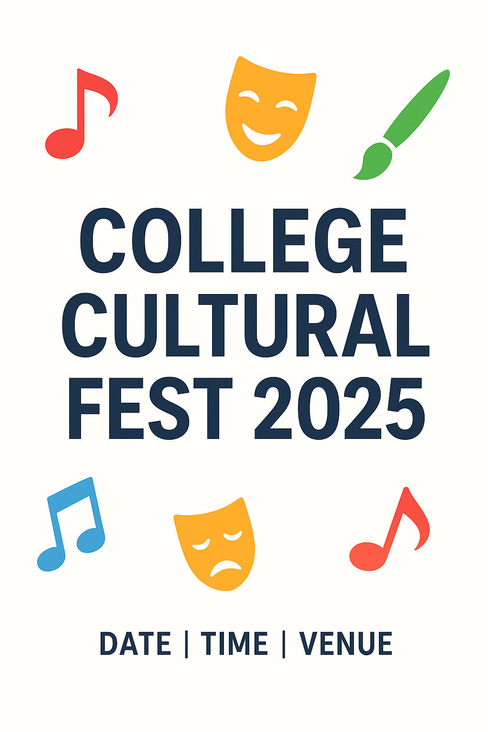

## **Task 3: Prompt Design Exercise**

### **1. ChatGPT (Text-based)**

**Prompt:** “Write a motivational speech (200 words) for college students starting their first year, focusing on curiosity, resilience, and building meaningful connections.”

**Output:**Speech for First-Year Students

Good morning everyone,

Welcome to the beginning of an exciting new chapter—your college journey. This is more than just the next step in your education; it is the foundation of who you are becoming.

First, I encourage you to embrace curiosity. Ask questions, explore new subjects, and go beyond what is taught in the classroom. Curiosity is the spark that will open doors to opportunities you never imagined.

Second, build resilience. College will not always be easy. There will be challenging classes, long nights, and moments of self-doubt. But resilience means standing back up, learning from setbacks, and pushing forward. Each challenge you overcome will prepare you for even greater successes.

Finally, never underestimate the power of connection. The friendships and relationships you build here can last a lifetime. Collaborate with classmates, learn from mentors, and be open to diverse perspectives. These connections will not only support you in tough times but will also enrich your journey.

So, as you begin this adventure, remember: stay curious, be resilient, and build meaningful connections. With these, you will not only succeed in college but also in life.

Thank you, and welcome to your journey!

### **2. DALL·E (Image-based)**

**Prompt:** “Create a futuristic city skyline at sunset with flying cars, neon lights, and eco-friendly skyscrapers covered in greenery. The style should be a mix of cyberpunk and utopian design.”

**Output:**

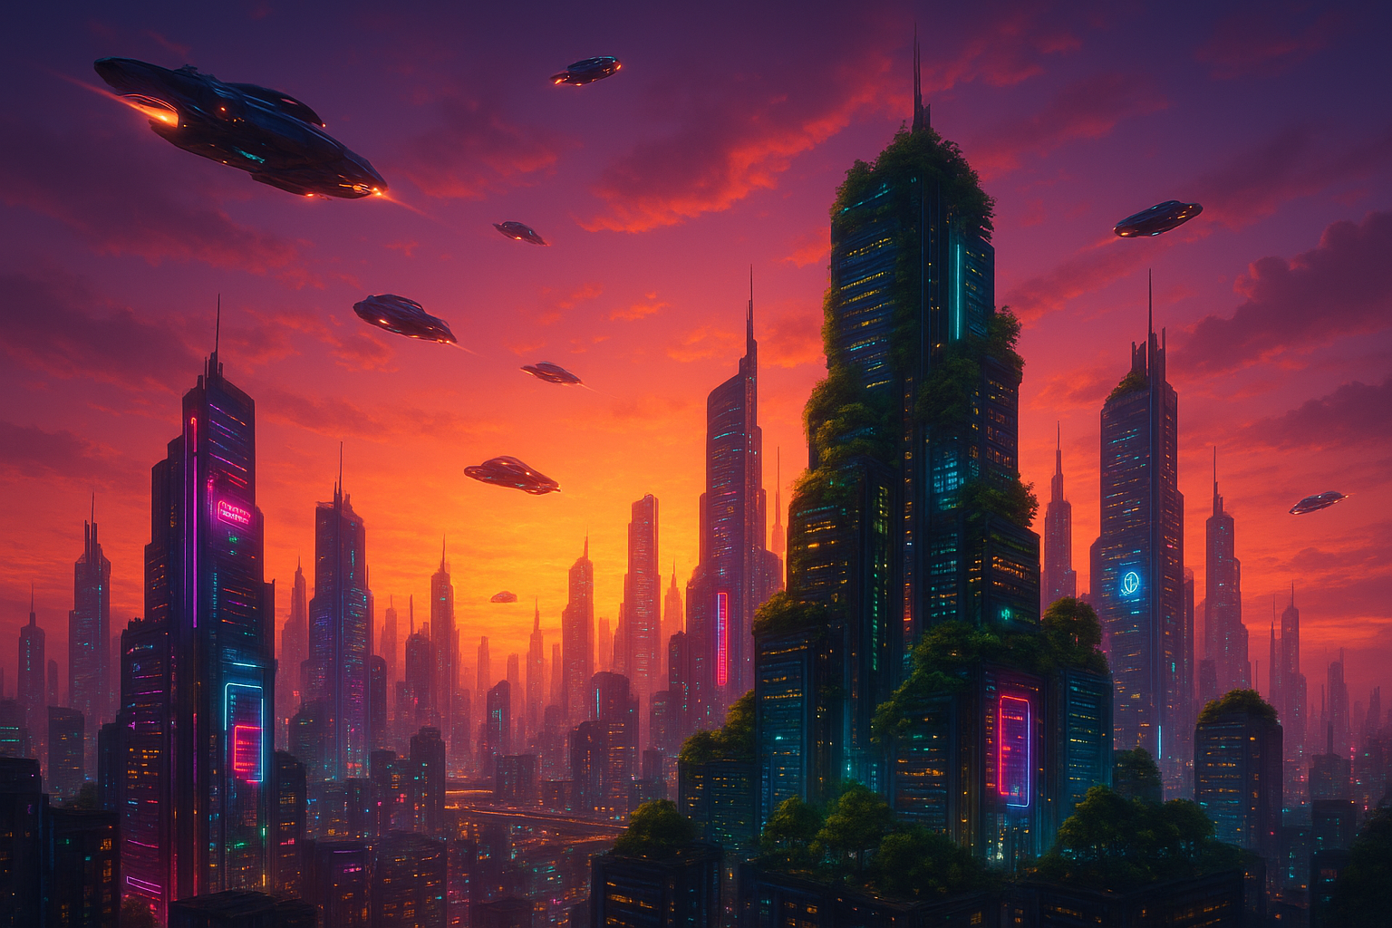

### **3. SORA (Video-based)**

**Prompt:** “Generate a 20-second cinematic video of a medieval fantasy battle scene where a lone knight stands on a cliff overlooking a vast army, with dramatic lighting and sweeping camera movement.”

**Output:**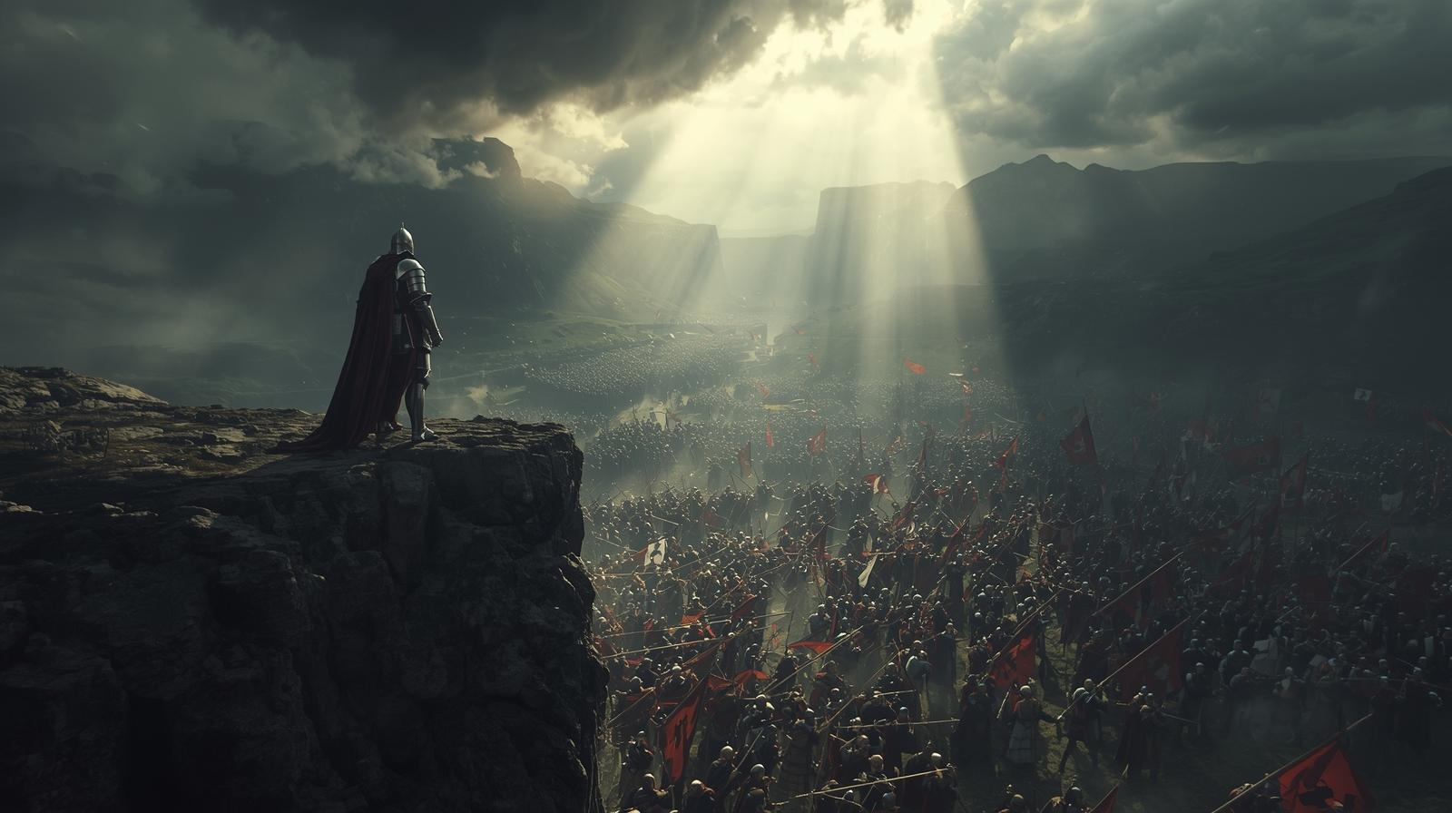

### **4. Coding / Logic**

**Prompt:** “Write a Python program that generates a weekly timetable for college classes. The program should accept subjects, number of classes per week, and available time slots, then output a structured timetable in table format.”

**Output:**

import random

import pandas as pd

def generate_timetable(subjects, slots_per_day, days):

# Create empty timetable

timetable = {day: [""] * slots_per_day for day in days}

# Flatten slots

total_slots = slots_per_day * len(days)

subject_slots = []

for subject, count in subjects.items():

subject_slots.extend([subject] * count)

if len(subject_slots) > total_slots:

raise ValueError("Not enough slots available for given subjects!")

# Shuffle and fill

random.shuffle(subject_slots)

slot_index = 0

for subject in subject_slots:

placed = False

while not placed:

day = days[slot_index // slots_per_day]

slot = slot_index % slots_per_day

if timetable[day][slot] == "":

timetable[day][slot] = subject

placed = True

slot_index = (slot_index + 1) % total_slots

# Convert to DataFrame for table format

df = pd.DataFrame(timetable, index=[f"Slot {i+1}" for i in range(slots_per_day)])

return df

# Example usage

subjects = {

"Math": 4,

"Physics": 3,

"Chemistry": 3,

"English": 2,

"Computer Science": 4,

}

days = ["Monday", "Tuesday", "Wednesday", "Thursday", "Friday"]

slots_per_day = 5

timetable = generate_timetable(subjects, slots_per_day, days)

print("\nWeekly College Timetable:\n")

print(timetable)

### **5. Education / Training**

**Prompt:** “Design an interactive quiz with 10 multiple-choice questions to teach high school students the basics of climate change, including causes, effects, and solutions. Provide immediate feedback for each answer.”

**Output:**

### Climate Change Quiz: Basics for High School Students

Instructions: Choose the correct answer for each question. You’ll receive immediate feedback.

Question 1:  
 What is the primary cause of recent global warming?  
 A) Volcanic eruptions  
 B) Human activities (burning fossil fuels)  
 C) Natural variations in sunlight  
 D) Earthquakes

*Feedback:*

* Correct: B) Human activities, such as burning coal, oil, and gas, are the main drivers of climate change.
* Incorrect: Other options contribute minimally or are natural phenomena, not the primary cause.

Question 2:  
 Which greenhouse gas is released the most by human activity?  
 A) Carbon dioxide (CO₂)  
 B) Methane (CH₄)  
 C) Nitrous oxide (N₂O)  
 D) Oxygen (O₂)

*Feedback:*

* Correct: A) CO₂ is the most emitted greenhouse gas from fossil fuel combustion.
* Incorrect: Methane and nitrous oxide are potent but less abundant; oxygen is not a greenhouse gas.

Question 3:  
 Which of the following is a direct effect of climate change?  
 A) Rising sea levels  
 B) Increased volcanic eruptions  
 C) More earthquakes  
 D) Changes in the Moon’s orbit

*Feedback:*

* Correct: A) Melting ice caps and thermal expansion cause sea levels to rise.
* Incorrect: Volcanic eruptions, earthquakes, and moon orbit changes are not caused by climate change.

Question 4:  
 Which human activity contributes the most to greenhouse gas emissions?  
 A) Driving cars and trucks  
 B) Planting trees  
 C) Using solar panels  
 D) Recycling

*Feedback:*

* Correct: A) Transport powered by fossil fuels releases significant CO₂.
* Incorrect: B, C, and D help reduce emissions, not increase them.

Question 5:  
 What is a major solution to reduce climate change?  
 A) Deforestation  
 B) Renewable energy sources  
 C) Burning more coal  
 D) Ignoring recycling

*Feedback:*

* Correct: B) Solar, wind, and hydro energy reduce reliance on fossil fuels.
* Incorrect: A, C, D worsen the problem instead of solving it.

Question 6:  
 Which of the following is a consequence of global warming?  
 A) Stronger storms  
 B) Stable weather patterns  
 C) Lower ocean levels  
 D) Less drought

*Feedback:*

* Correct: A) Higher temperatures intensify storms, heatwaves, and extreme weather.
* Incorrect: Global warming causes more instability, not stability.

Question 7:  
 Which gas traps heat in the Earth’s atmosphere?  
 A) Oxygen  
 B) Nitrogen  
 C) Carbon dioxide  
 D) Helium

*Feedback:*

* Correct: C) Carbon dioxide, along with methane and nitrous oxide, traps heat (greenhouse effect).
* Incorrect: Oxygen, nitrogen, and helium do not trap heat.

Question 8:  
 Why is deforestation harmful for climate?  
 A) Trees release oxygen when cut  
 B) It reduces the number of carbon-absorbing plants  
 C) It creates more clouds  
 D) It decreases rainfall only

*Feedback:*

* Correct: B) Fewer trees mean less CO₂ is absorbed from the atmosphere.
* Incorrect: A, C, D are misconceptions; deforestation increases CO₂, contributing to warming.

Question 9:  
 Which sector is a significant contributor to methane emissions?  
 A) Agriculture (livestock)  
 B) Electronics  
 C) Fishing  
 D) Aviation

*Feedback:*

* Correct: A) Livestock produce methane during digestion, a potent greenhouse gas.
* Incorrect: Electronics, fishing, and aviation contribute less methane.

Question 10:  
 What can individuals do to fight climate change?  
 A) Use public transport, save energy, plant trees  
 B) Burn more coal at home  
 C) Waste food and resources  
 D) Avoid renewable energy

*Feedback:*

* Correct: A) Simple actions collectively reduce carbon footprint.
* Incorrect: B, C, D worsen climate change.